**UNIVERSITY OF ENGINEERING TECHNOLOGY PESHAWAR**

19

**LAB REPORT NO-1**

**COMPUTER FUNDEMENTAL**

**Submitted by: ASHFAQ AHMAD**

**AMIR SULIMAN**

**Submitted to: AMAAD KHALIL**

**Department: CSE**

**Class no: 31,42**

**Section: B**

**Batch: 21**



**COMPUTER:**

* It is Electronic device which convert data into useful information.
* **Essential parts of computer**

There are four main parts of computer

1. Hardware
2. Software
3. Data
4. User

**I.HARDWARE**

* The parts of computer which we touch or exist physically are called hardware.

Hardware consist of the following parts,

1. Input devices
2. Output devices
3. Processing devices
4. Memory devices
5. Storage devices

**1. Input devices:**

* Those devices with the help of which give data to computer are called input devices.

**Examples:** mouse, keyboard, joysticks, trackball, scanner etc.

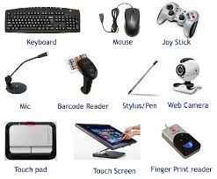

**2.** **Output devices:**

* Those devices by which we accept information from computer is called Output devices.

**For example:** loud speaker, screen, projector, image scanner e.t.c

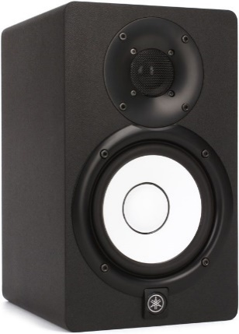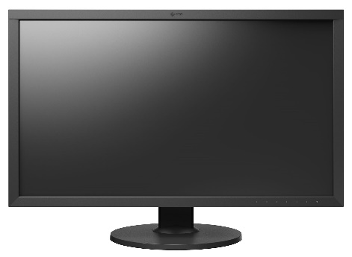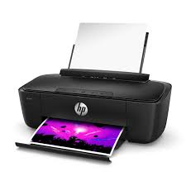

**3. Processing device:**

* It is also essential hardware of computer.
* A **processing device** is any device in a computer that handles the intermediate stage of processing the incoming data.

Some of the most common processing devices include; **1)** **Motherboard:**

* The **motherboard** is a printed [circuit board](https://www.computerhope.com/jargon/p/pcb.htm) and foundation of a computer that is the biggest board in a computer [chassis](https://www.computerhope.com/jargon/c/chassis.htm).
* It allocates power and allows communication to and between the [CPU](https://www.computerhope.com/jargon/c/cpu.htm), [RAM](https://www.computerhope.com/jargon/r/ram.htm), and all other computer [hardware](https://www.computerhope.com/jargon/h/hardware.htm) components.

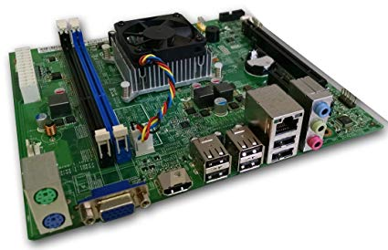

**2) Central processing unit (CPU):**

* It is the main part of any computer system. It describes how control unit cycles through fetch, decode and execute operations to carry out program instructions stored in main memory.

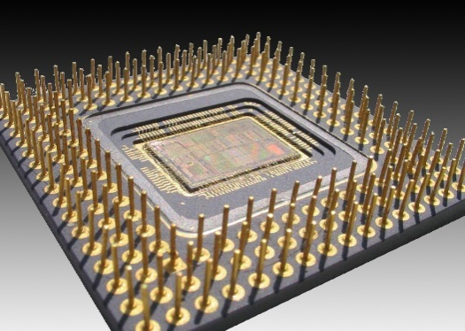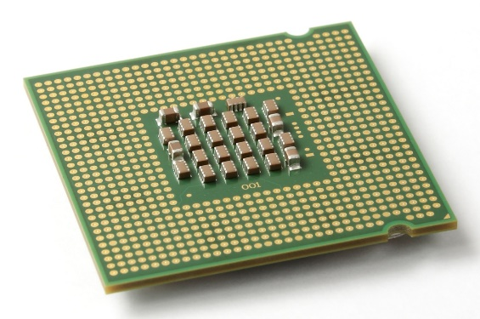

Fig. 3.a fig3.b

**Components of CPU are:**

[**ALU**](https://www.computerhope.com/jargon/a/alu.htm)**(arithmetic logic unit)** – performs mathematical, logical, and decision operations.

[**CU**](https://www.computerhope.com/jargon/c/contunit.htm)**(control unit)** – directs all the processors operations.

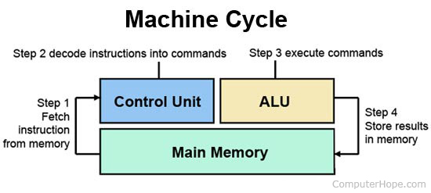

**4. Memory devices:**

* The device which stores data either permanently or temporarily.
* **Types of memory devices:**

**1) Internal processor Memory:**

* These memories are directly accessible to the CPU.
* They are extremely fast memories.
* **Examples** of such memories are:

1. **Cache memory:** it is small amount of high-speed semiconductor memory which exists inside the microprocessor or on the motherboard.

**There are three different categories of cache memory**

**L1:** built into microprocessor chip and is smallest in size

**L2:** a separate chip between CPU and the RAM

**L3:** larger than L1 and take longer time to access

1. **Processor Registers:** they are small memory units used to temporarily store binary information and pass it on the other parts of processor or main memory during execution.

**2) Random Access Memory (RAM):**

* It is volatile and READ/WRITE memory which is used for the storage of **active** programs and data.
* It will lose all stored information if the power is turned off.

**Types of RAM:**

1. **Static RAM:** it uses transistor to store a single bit and does not need periodic refreshment to maintain data.
2. **Dynamic RAM:** it uses a separate capacitor to store a single bit and needs periodic refreshment to maintain the charge in the capacitors for data.

* **Synchronous DRAM:** the processor and memory timing are linked. This allows more efficient processor memory
* **Asynchronous DRAM:** the processor timing and the memory timing were independent. Thus the processor has to wait until the memory is open to access.

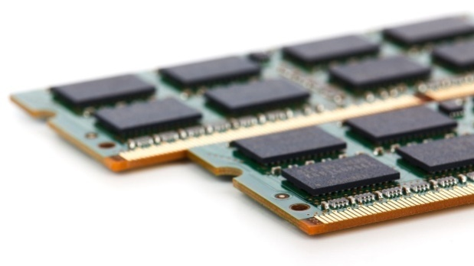

Fig. 6

**3) Read Only Memory (ROM):**

* It is a non-volatile memory refers to computer memory chips containing permanent or semi-permanent data.
* Even after the power is turned off the information is not lost.

**Types of ROM:**

1. **PROM:** programmable ROM that can be modified only once by a user.
2. **EPROM**: erasable programmable ROM that can be erased and reused
3. **EEPROM:** Electrically erasable programmable ROM that can be erased and reprogrammed repeatedly through a normal electrical voltage.

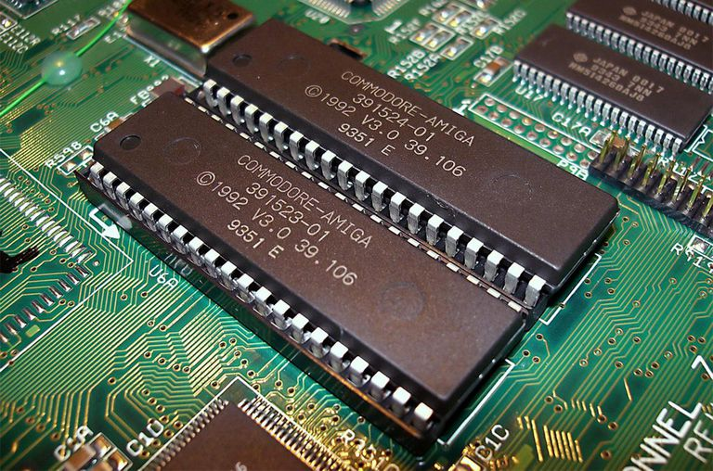

Fig. 7

**5) Storage devices:**

* The device which stores data permanently even when there is no power supply.
* It is non-volatile memory.
* It is flat round in shape rotating around its center

**Types of storage devices**

1. Magnetic storage devices
2. Optical storage devices

**1) Magnetic storage:**

* Magnetic storage devices store data in the form of tine magnetized dots.
* These dots are created, read and erased using magnetic fields created by very tiny electromagnets.

**Example;**

1. **Hard disks:** A hard disk drive is a non-volatile computer storage device containing magnetic disks or platters rotating at high speeds.
2. **Magnetic tape:** these devices store data by using their magnets.

**2) Optical Devices:**

* Optical storage is any storage type in which data is written and read with a [laser](https://whatis.techtarget.com/definition/laser).

**Example;**

1. CD ROM
2. DVD
3. Blue-ray Disk

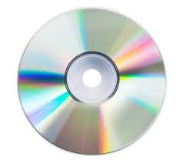

Fig. 10

Different Generations of Computers:

The main difference between the different generations is the amount of energy it uses. As you go up the generation, they generally use the energy more efficiently, which results in good performance. Intel has a tick, tock method which means that if you go from first to second gen, you will generally not notice it but if you go from first to third you will notice a big jump the fourth gen are the best for power users and fifth generation for people that needs something with a long battery life.

# Intel Processors:

* They were selected to be first in use so they are first generation of processors.

**SATA:**

* It is a computer bus interface that connects host bus adapters to mass storage devices such as hard disk drives, optical drives, and solid-state drives.

**PATA:**

* Paralleled (**Parallel Advanced Technology Attachment**) is a standard for connecting hard drives into computer systems.

**PENTIUMS:**

**Pentium 1:**

* A family of 32 and 64-bit x86-based CPU chips from Intel. The term may refer to the chip or to a PC that uses it. During their reign, **Pentium** chips were the most widely used CPUs he world for general-purpose computing.

**Pentium 2:**

* The **Pentium II**  brand refers to Intel's sixth-generation micro architecture ("P6") and x86-compatible microprocessors introduced on May 7, 1997

**Pentium 3:**

* The **Pentium III** (marketed as Intel **Pentium III** Processor, informally PIII, also stylized as **Pentium**) brand refers to Intel's 32-bit x86 desktop and mobile microprocessors based on the six. **PATA** generation P6 micro architecture introduced on February 26, 1999.

**Pentium 4:**

* **Pentium 4** is a line of single-core central processing units (CPUs) for desktops, laptops and entry-level servers introduced by Intel on November 20, 2000 and shipped through August 8, 2008.

**Cores:**

**Core i3:**

* Developed and manufactured by Intel, the **Core i3** is a dual-**core** computer processor, available for use in both desktop and laptop computers.
* It is one of three types of processors in the "I " series (also called the Intel **Core** family of processors)

**Core i5:**

* Developed and manufactured by Intel, the **Core i5** is a computer processor, available as dual-**core** or quad-**core**.
* It can be used in both desktop and laptop computers, and is one of three types of processors in the "i" series (also called the Intel **Core** family of processors).

**Core i7:**

* Intel **Core i7** is a name that the company Intel uses for the computer processors it makes for high-end desktop and laptop computers and tablets. ... Instead, it is the name for all of the fast processors that Intel thinks should be sold to consumers

**Core2D:**

* **Core2D** is a multi-platform application for making data driven 2D diagrams.

**Dual Core:**

* **Dual**-**core** refers to a CPU that includes two complete execution cores per physical processor. It has combined two processors and their caches and cache controllers onto a single integrated circuit (silicon chip).

**THE END**